Router

📡 What is a Router?
# Source: Chatgpt (GPT‑5 Mini) at [12/18/2025]
A router is a network device that connects different networks together and directs data traffic between them. It is most commonly used to connect a local area network (LAN) (like your home or office) to the internet (a wide area network or WAN).

🔧 Key Functions of a Router
# Source: Chatgpt (GPT‑5 Mini) at [12/18/2025]
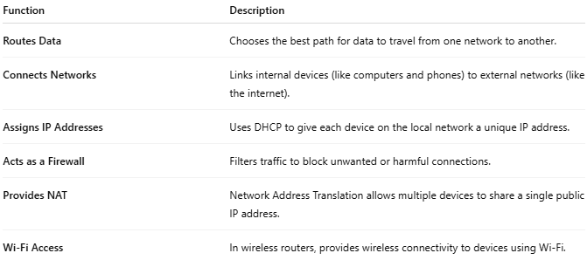

Function | Description
Routes Data | Chooses the best path for data to travel from one network to another.
Connects Networks | Links internal devices (like computers and phones) to external networks (like the internet).
Assigns IP Addresses | Uses DHCP to give each device on the local network a unique IP address.
Acts as a Firewall | Filters traffic to block unwanted or harmful connections.
Provides NAT | Network Address Translation allows multiple devices to share a single public IP address.
Wi-Fi Access | In wireless routers, provides wireless connectivity to devices using Wi-Fi.

🏠 Example: Home Network Router
# Source: Chatgpt (GPT‑5 Mini) at [12/18/2025]
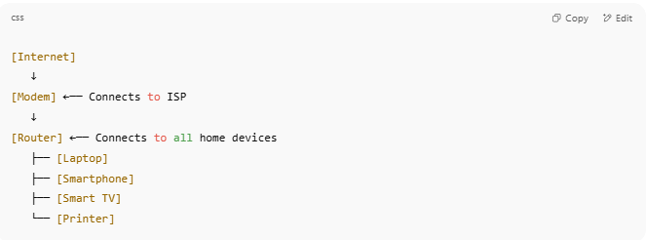
[Internet]
↓
[Modem] ←── Connects to ISP
↓
[Router] ←── Connects to all home devices
├── [Laptop]
├── [Smartphone]
├── [Smart TV]
└── [Printer]

📌 Types of Routers
# Source: Chatgpt (GPT‑5 Mini) at [12/18/2025]
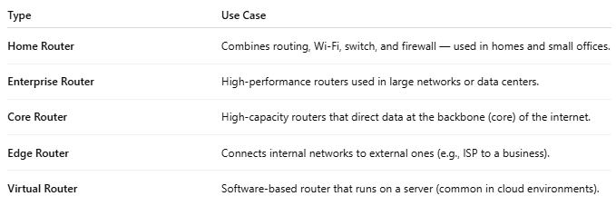

Type | Use Case
Home Router | Combines routing, Wi-Fi, switch, and firewall — used in homes and small offices.
Enterprise Router | High-performance routers used in large networks or data centers.
Core Router | High-capacity routers that direct data at the backbone (core) of the internet.
Edge Router | Connects internal networks to external ones (e.g., ISP to a business).
Virtual Router | Software-based router that runs on a server (common in cloud environments).

